Instructional Program Review
Annual Follow-up Instructions

The Instructional Program Review Annual Follow-up is documented in the attached Excel workbook. The follow-up consists of several Excel tabs. The workbook is updated annually by the Program Coordinator or designee.
PROGRAM REVIEW PROCESS NOTES
Cycle: 2019-2020 only- Follow-up forms will be submitted twice once in August and January due to finding from the Institutional Effectiveness Committee review of the process. Going forward, Program Review Annual Follow-ups will be due in January.
Task Updates: Task for this plan are expected to be updated as progress is made, task removed as research or needs become obsolete, or added to as new items should come from current task work.
Communication: It is up to the program faculty to communicate together about the specifics of current task, future task, removal of task, etc. Instructional programs should be working through current task as well as documenting in the follow-up new task or directions in which the program will be going as a result of research and information. Programs should assign task to program faculty as needed. It is also important to have regular communication with Instructional Deans about program review as well as continuous communication throughout the year with program faculty about the progress of the plan.
Timelines: Timelines should be realistically set to the specific task and level of involvement. More time should be set for thing that require meetings or others to help make decisions. Always remember that task that require budgetary items should follow a timeline pertain into the opening of the next year’s budget (January to March)..
Budgetary Items: Some activities within the program review may require funds. Budget cycle typically begins in January. This is the time in which the programs should put in request pertaining to their program review. Please make sure to denote that the item is related to continues progress on the plan.

COMPLETING THE ANNUAL FOLLOW-UP
- Tab 1: Objective Dashboard.
  - This tab doesn’t require any updates.
  - This tab is updated by the Office of Institutional Effectiveness after the program has submitted the final information.
- Strategy Tabs (Yellow Tabs)
  - Each plan is has a different amount of tabs depending on each strategy in the individual plan
  - Each tab needs to be updated.
    - Step 1- Update current task
      - Update the Task Status (Use the dropdown menu to select the status)
      - Update the Grayed Columns
        - Task % Completed: Increments of 25%. If completed, select 100% and make sure the put in the date completed.
        - Date Completed: Put in the date that specific task was completed. Task % should be 100%.
        - Assessment Results- This is be narrative describing what was determined based on the task. This narrative should tie to the task written.
        - Use of Results: Using results of the task, place in narrative of if it led to different focuses, does it lead to improvements to be used in the future, and/or does it accomplish the overall goals.
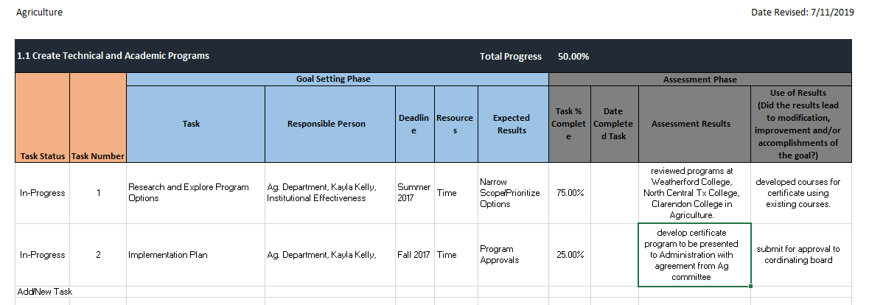
      - Note: If deleting a task or placing one on hold, the program must complete the assessment results to explain why the program has elected to delete a task or placed a task on hold.

    - Step 2-Add New Task
      - Programs are expected to continue to add new task as other task are completed. This process is on-going for the programs
      - Task Status-Make sure to select the option from the drop-down box.
      - Task Number- Only whole numbers should be entered.
      - Goal Setting Phase (Blue Headings)
        - Task- Explanation of what this specific item requires. For good measure, keep it simple, but descriptive.
        - Responsible Person(s)-Select the stakeholders for this task. Depending on the task it could be the whole department as well as other areas of the college or community. Be specific when needed.
        - Deadline: Task should have an end date. If not, go back and break down the task into smaller parts/steps. Give a reasonable amount of time knowing the amount of time or how many stakeholders are involved to get the task complete.
        - Recourses: Many times task require time and human capital versus funds. If money is involved, try to put a dollar amount to the item. If not, a range might be a better option. Placing a targeted amount in the field will help during budget times to estimate cost.
        - Expected Results: This column answers what does the program expect when the task is completed. Does it require another step? Does it increase enrollment, retention, completion?
      - Assessment Phase (Grey Headers)
        - This section would be completed in the next follow-up unless the actual task entered has been completed.
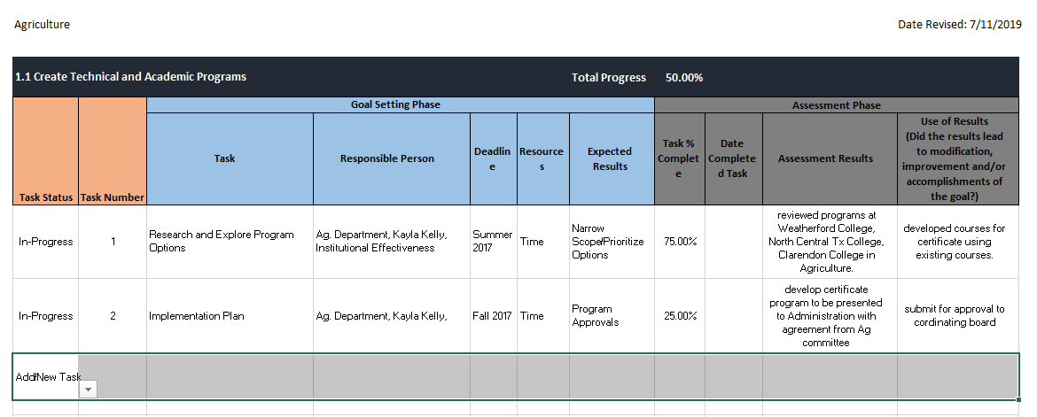
- Process
  - Excel spreadsheets are email to Office of Institutional Effectiveness
    - Sherry Davis, shdavis@hillcollege.edu or
    - Gabby Smith gsmith@hillcollege.edu
  - Deadline January 30
  - What’s Next
    - Office of Institutional Effectiveness
      - Reviews the follow-up document and will contact program coordinators to discuss any questions, updates and/or changes.
      - Update of the Objective Dashboard
        - Percentages will be reviewed for accuracy
        - Notes added to explain changes or updated, if needed
      - Finalized document is created and sent to Instructional Deans and Program Coordinators
    - Instructional Programs
      - Action in the plan by completing task and creating new task to meet the objective.
      - Communication within the department about task and forward progress
      - Communication with Deans of Instruction about plan progress
      - Communication with the Office of Institutional Effectiveness, if assistance is needed.

